1. HASH FUNCTION – MD5
Aim
To implement the MD5 hash function using Python and generate the hash value for a given message.
Algorithm
- Import the hashlib module.
- Read the message from the user.
- Convert the message into bytes using encode().
- Apply the MD5 hash function using hashlib.md5().
- Convert the hash into hexadecimal format using hexdigest().
- Display the original message and MD5 hash value.
Program
import hashlib
message = input("Enter the message: ")
md5_hash = hashlib.md5(message.encode()).hexdigest()
print("Original Message:", message)
print("MD5 Hash:", md5_hash)
Output
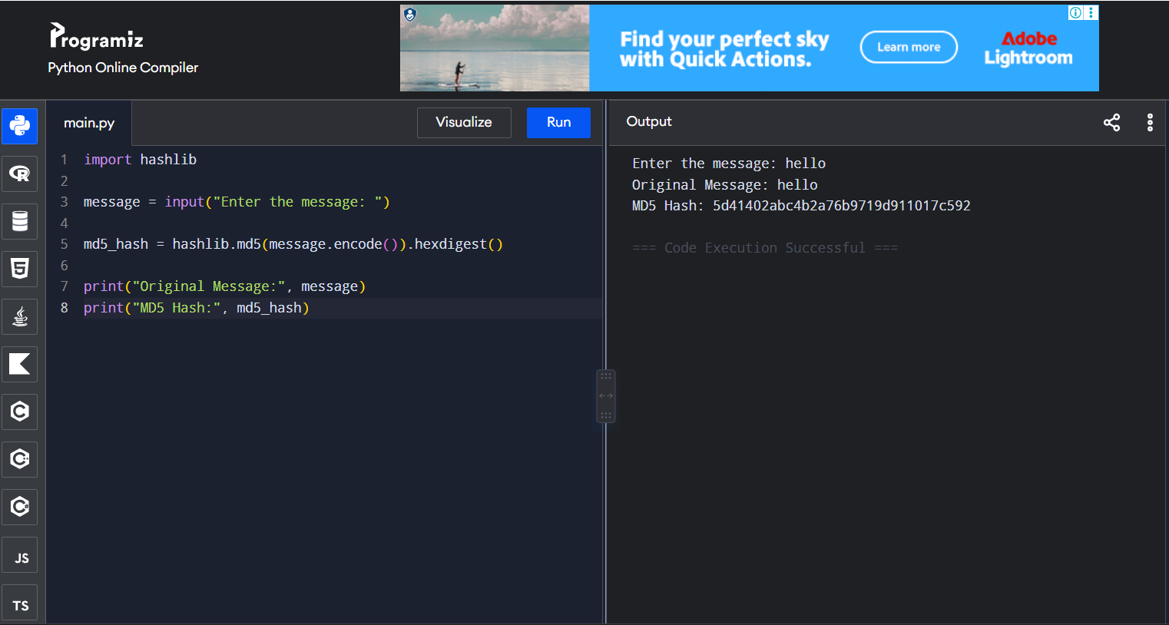
Result
The MD5 hash of the given message was successfully generated.

